

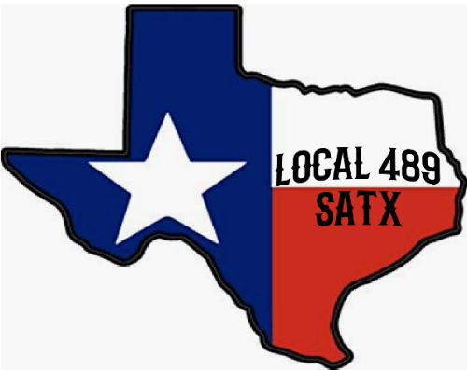

**IN CASE OF**

**EMERGENCY**

**ON THE RAILROAD**